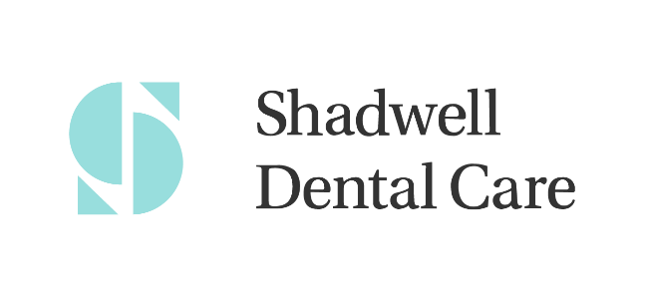

Failed to Attend and Short Notice Cancellation Policy
At Shadwell Dental Care we aim to provide all our patients with excellent patient care and to achieve this, we kindly ask for your cooperation. If you cannot attend your appointment, we request that you give us as much notice as possible. We require at least 48 hours’ notice so that we can allocate the time to someone else who may need that appointment. If you fail to attend or make short notice cancellations (without giving the practice 24 hours’ notice) on three occasions, this will result in a charge of £2 per minute. The charge will depend on the length of the appointment missed.

Practice Protocol:

- In the first instance of an FTA or short notice cancellation, an SMS or email will be sent to the patient informing them of their missed appointment.
- If the patient FTA’s or cancels short notice for the second time, we will send an email or a letter to the patient informing them of their missed appointment details and that there will be a charge if a further appointment is missed/cancelled short notice.
- In the event of a third FTA/short notice cancellation, a charge will be applied to the patient’s record of £2 per minute and the patient will be unable to make any further appointments until this is settled. The charge will depend on the length of the final appointment missed.

We send reminders to all our patients 48 hours prior to their appointment. We appreciate that sometimes the cancellation of appointments is unavoidable, but we ask that you give as much notice as possible to enable us to provide a gold standard of care to all our patients.

Reviewed 11/06/25

